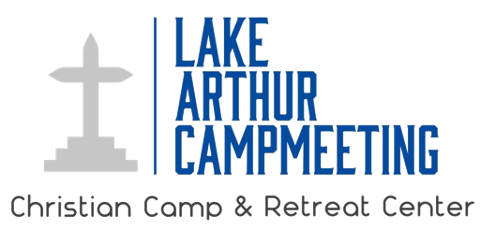
Contact Information:
Lake Arthur Campmeeting
337-774-7783
info@lakearthurcampmeeting.org

FOR IMMEDIATE RELEASE

LAKE ARTHUR CAMPMEETING presents MARK HAYES IN CONCERT

Lake Arthur, La. – To celebrate 125 years since its founding, the Lake Arthur Campmeeting Association will present an evening of gospel, jazz, classical and inspirational music from legendary pianist and arranger, Mark Hayes. Concert will begin at 7:30 pm on June 24th at the historic Lake Arthur Campmeeting Christian Camp and Retreat Center.

Mark Hayes is an internationally known and award-winning concert pianist, composer, arranger and conductor. His personal catalog, totaling over 1,500 published works, includes work for solo voice, solo piano, multiple pianos, orchestra, jazz combo, small instrumental ensembles, and choruses of all kinds. In 2010 Baylor University Center for Christian Music Studies awarded Mark the Award for Exemplary Leadership in Christian Music. Mark arranged and orchestrated the music for Civil War Voices, which won six awards including “Best Musical” in the 2010 Midtown International Theatre Festival in New York. He conducted the world premiere of his work for chorus, orchestra and narrator, The American Spirit, at Lincoln Center in May 2011 and the world premiere of his Requiem in Lincoln Center in May 2013. In October 2014 Hayes conducted his Requiem at St. Ignatius Basilica in Rome, Italy as part of The Festival Pro Musica E Arte Sacra, sponsored by the Vatican. He regularly conducts his works for chorus and orchestra at Carnegie Hall and Lincoln Center. Whether concertizing on the other side of the globe or composing at his home in Kansas City, Missouri, Mark is blessed to live out his mission "to create beautiful music for the world".

The concert is free and open to the public. Seating will be general admission in the historic tabernacle built in 1898: 100 Campground Lane, Lake Arthur, LA.

The Lake Arthur Campmeeting Association is an interdenominational Christian family camp and retreat center founded in 1895. Located on the northern shore of Lake Arthur, the grounds span over 10 acres and feature live oaks, cypress trees, and waterfront views that capture the beauty of Louisiana at its best. The primary purpose of the ministry is to strengthen families through faith, fun, and fellowship.

Learn more at www.lakearthurcampmeeting.org
www.markhayes.com

Optional press photos

